KONSTANTIN KURYLEV
Doctor of Sciences

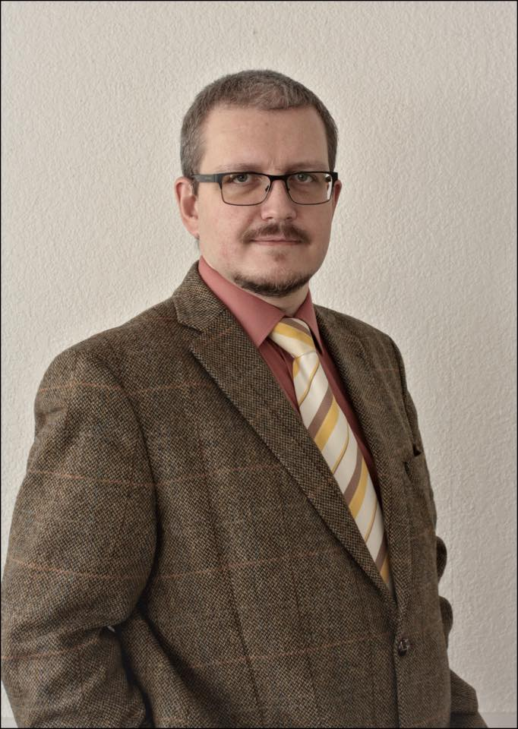
Contact Information
Current Address:
Academic Bakulev Str. 6, apartment 286
117513 Moscow, Russia
E-Mail: kuryljov@narod.ru
Tel.: +7 903 127 77 81

Personal Information
Date of birth: 05/07/1975
Country of origin: Russia

Languages

- Russian (native proficiency)
- English (professional working proficiency)
- French (professional working proficiency)

Education
2016
Degree: Doctor of Historical Sciences

1999 – 2002
Peoples' Friendship University of Russia, Moscow, Russia
Faculty: Humanitarian and Social Sciences
Department: Russian History
Degree: Candidate of Historical Sciences

1997 – 1999
Peoples' Friendship University of Russia, Moscow, Russia
Faculty: Humanitarian and Social Sciences
Department: Russian History
Degree: Master of Russian History, Diploma with Honours

1997 – 1999
Peoples' Friendship University of Russia, Moscow, Russia
Faculty: Foreign Languages
Diplomas: Interpreter from English Language; Interpreter from French Language

1992 – 1997
Peoples' Friendship University of Russia, Moscow, Russia
Faculty: Humanitarian and Social Sciences
Department: Russian History
Degree: Bachelor of Russian History, Diploma with Honours

Work Experience
2003 – present
Associate Professor at the Department of Theory and History of International Relations, Deputy Head of the Department of Theory and History of International Relations on the scientific work, Peoples' Friendship University of Russia, Moscow, Russia

2001 – 2003
Assistant at the Department of Theory and History of International Relations, Peoples' Friendship University of Russia, Moscow, Russia

1999 – 2001
Lecturer at the Department of Foreign Languages, Moscow regional institute of higher socio-economic education, Vidnoye, Russia

1999 – 2000
Acting Head of the Department of Foreign Languages, Moscow regional institute of higher socio-economic education, Vidnoye, Russia

Advanced Trainings
November 2016
Course “Leading journals of the world in the social sciences: how to read and write articles in Scopus”, Peoples' Friendship University of Russia, Moscow, Russia

February 2016
Course “Work with Telecommunication educational information system”, Peoples' Friendship University of Russia, Moscow, Russia

September 2010
Course “Methods of teaching general and special disciplines in Russian for foreign students”, Peoples' Friendship University of Russia, Moscow, Russia

March – May 2009
Course “Information technology in education process. Computer testing”, Peoples' Friendship University of Russia, Moscow, Russia

October – November 2008
Course “Foreign Language (English)”, Peoples' Friendship University of Russia, Moscow, Russia

February – June 2006
Course “Information technology in education”, State Academy of Innovations, Moscow, Russia

September 2004
Course “Methods of teaching general and special disciplines in Russian for foreign students”, Peoples' Friendship University of Russia, Moscow, Russia

Membership
2011 – present
Member of the University Association for Contemporary European Studies (UACES), London, United Kingdom
2017 – present
Member of the International Studies Association (ISA), San Francisco, USA

